**:** Configure fast Ethernet on router using packet tracer

**Components:** Router, Switches, PC’s

**Theory:** Fast Ethernet is used for departmental backbones, connections to high-speed servers, and connections to workstations running bandwidth-intensive software such as CAD or multimedia applications.

**Cisco Packet tracer Setup:**

**Implementation:**

**Step 1:** Arrange all devices as shown below:

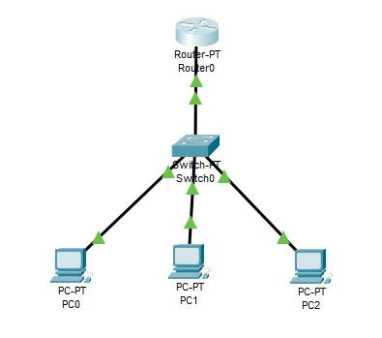

**Step 2:** Configure Router using CLI, using following commands:

configure t hostname R1 enable password cisco interface fa0/0

ip address 192.168.2.1 255.255.255.0

no shutdown

exit Exit



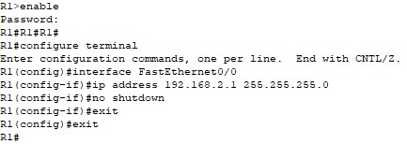

**Step 3:** Configure All PC’s and check the connection.

|  |  |  |  |
| --- | --- | --- | --- |
| **Device** | **Interface** | **IPv4 address** | **Other** |
| PC0 | IP config | 192.168.2.2 | Default Gateway: 192.168.2.1 |
| PC1 | IP config | 192.168.2.3 | Default Gateway: 192.168.2.1 |
| PC2 | IP config | 192.168.2.4 | Default Gateway: 192.168.2.1 |

**Step 4:** Ping 192.168.2.1 with all the PCs.

**Output:**

